**Subdomain:** A subdomain is a prefix added to a domain name to separate a section of your website. Site owners primarily use subdomains to manage extensive sections that require their own content hierarchy, such as online stores, blogs, job boards or support platforms. Subdomains function as a separate website from its domain.

You don't have to pay for subdomains if you already have a domain name.

A  subdirectory is often a better choice for SEO

Q1- Create a Website:

Step 1: Created a main directory and subdomain

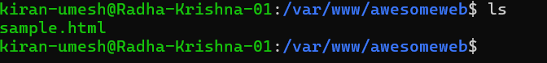

Created a new config file for new domain awesomeweb by copying the default file and updating it to new domain location:

Added the new domain/site under the enabled sites using the default file and updated it accordingly:

Started nginx:

Obtained the IP address of the site that has been running:

Validated that sample site is up and running:

